Completing Background Check After Volunteer Form is Done
If you don’t have a current AYSO Volunteer Form done, do that before following these steps.

- Log into your Region website where you volunteered.
- On the left side of the My Account page, click on the Volunteer Tab.
- Go to the Certification Status box below your name and position.
- Check the box next to Risk Status (Background Check Status)
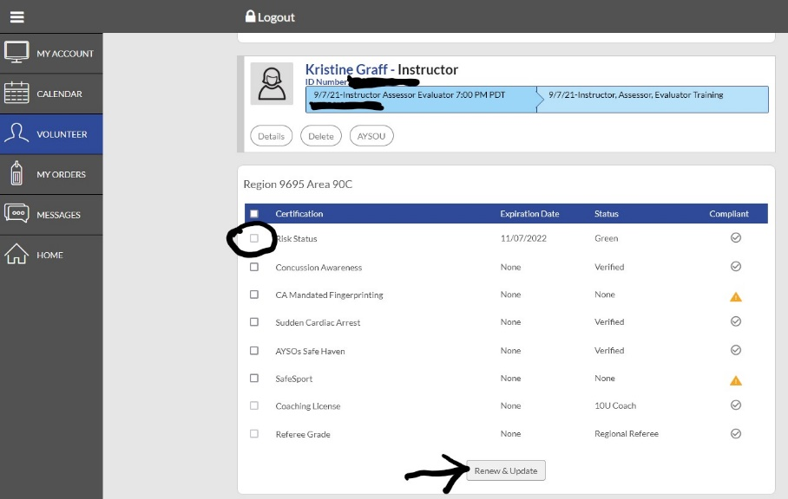
- Click button at the bottom of the box “Renew and Update”.

- Go to your email (the address on your volunteer form), find the email from TheAdvocates@sterlingvolunteers.com.
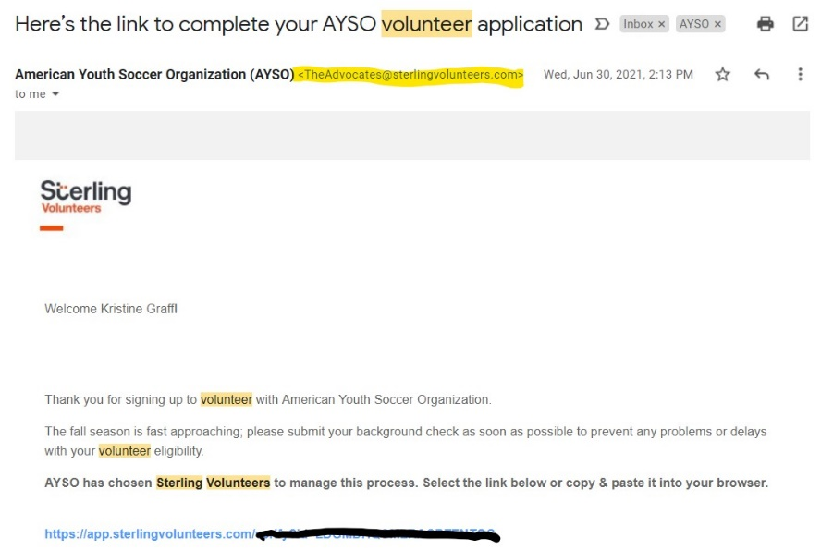

- Click the link in the email to go directly to Sterling Volunteers.
- Log in if you are a returning volunteer, create an account if you are a new volunteer.
- Complete the background check process.

Thank You for Completing your Background Check!!

